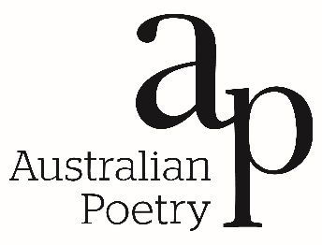

APPLICATION FORM

Please attach your application form to all other material and submit as a single PDF document to nahr.ap.submissions@gmail.com

Name ................................................................................................................................................................

Address ................................................................................................................................................................................................................................................................................................................................

Email ................................................................................................................................................................

Bio-note (200 words), where possible please include a link to professional web page ................................................................................................................................................................................................................................................................................................................................................................................................................................................................................................................................................................................................................................................................................................................................................................................................................................................................................................................................................................................................

In signing this form, I confirm the following:
>> I am an Australian citizen/ permanent resident of Australia
>> I am a current subscriber to Australian Poetry
>> the creative work submitted as part of this application is wholly my own
>> it is the awardee’s responsibility to fund their own travel to and from Taleggio
>> domestic travel in Italy, and food expenses while in Taleggio, are to be covered by the awardee

Signature ................................................................................................................................................................

Date ................................................................................................................................................................

